Organic Juices 16oz.

Fresh Apple or Orange $5.49

Just Grapefruit $5.79

Simply Carrot $5.99

Allergy Relief Apple, Celery, Cranberry, Nettle Tea, Orange, Parsley $7.99

Detox Apple, Burdock Root Tea, Celery, Cucumber, Ginger, Lemon, and Parsley $7.99

Immunity Apple, Bell Pepper, Carrot, Celery, Ginger, Kale, and Lemon $7.99

Refresher Apple, Cucumber, Ginger, Kale, Lemon, and Pineapple $7.99

Roadrunner Apple, Carrot, Ginger, Kale, Lemon, Spinach, and Turmeric $7.99

Sunburst Apple or Orange, Carrot, and Ginger $7.99

Transfusion Apple, Beet, Carrot, Celery, and Ginger $7.99

Very Veggie Bell Pepper, Carrot, Celery, Cucumber, Cyclone Cider, Kale, Lemon, and Tomato $7.99

Adrenagizer Apple, B-12, Cherry, Chloroxogen, Cucumber, Lemon, Schisandra Tea, and Strawberry $8.99

Create Your Own Juice 16oz.
Pick 5:

Base: Apple, Carrot, Orange, Cucumber

Everything Else: Beet, Bell Pepper, Celery, Kale, Spinach, Ginger, Lemon, Parsley, Tomato $7.99

Organic Smoothies 16oz.

Allergy Relief Coconut Milk, Hempseed, Honey, Nettle Tea, and Pineapple $7.99

Amazon Power Almond Milk, Acia, Banana, Cacao, Hempseed, Spinach, and Strawberry $7.99

Apple Pie Almond Milk, Apple, Banana, Cashew, Cinnamon, Date, and Ginger $7.99

Blueberry Cobbler Coconut Milk, Almond Butter, Bee Pollen, Blueberry, Cherry, Cinnamon, and Maca $7.99

The Cure Orange Juice, Banana, Cranberry, Ginger, Hempseed, and Vitamin-C $7.99

Energy Coconut Milk, Almond Butter, Banana, Bee Pollen, Honey, Maca, and Strawberry $7.99

PB&J Coconut Milk, Agave, Grape Concentrate, Peanut Butter, Strawberry, and Vegan Vanilla Protein $7.99

Red Velvet Hazelnut Chocolate Milk, Cherry, Strawberry, Spinach, and Thinberry Protein $7.99

Tropical Green Orange Juice, Mango, Pineapple, Banana, Coconut Oil, Maca, Ginger, and Spinach $7.99

Create Your Own Smoothie 160z.

Base: Coconut Milk, Almond Milk, Hazelnut Chocolate Milk, Orange Juice, Apple Juice

Pick 2 Fruits or Veggies: Apple, Kale, Spinach, Strawberry, Mango, Pineapple, Banana

Add Protein: Whey, Pea, Hemp, Vegan, Rice, Thinberry, or Others Upon Availability
$7.99

*Ask Your Juicer about other Seasonal Drinks*

Healthy & Organic Additions

$0.25

Extra Fruit / Veggie
Agave
Honey
Flaxseed
Chia Seed
Vit-C Ascorbate

$0.50

Bee Pollen
Hempseed
Maca
Almond Butter
Cacao
Date (1)
Turmeric

$0.75

Protein Powders (ask about selections)
Superfood Proteins
Vit-C Camu Camu

Other Healthy Options

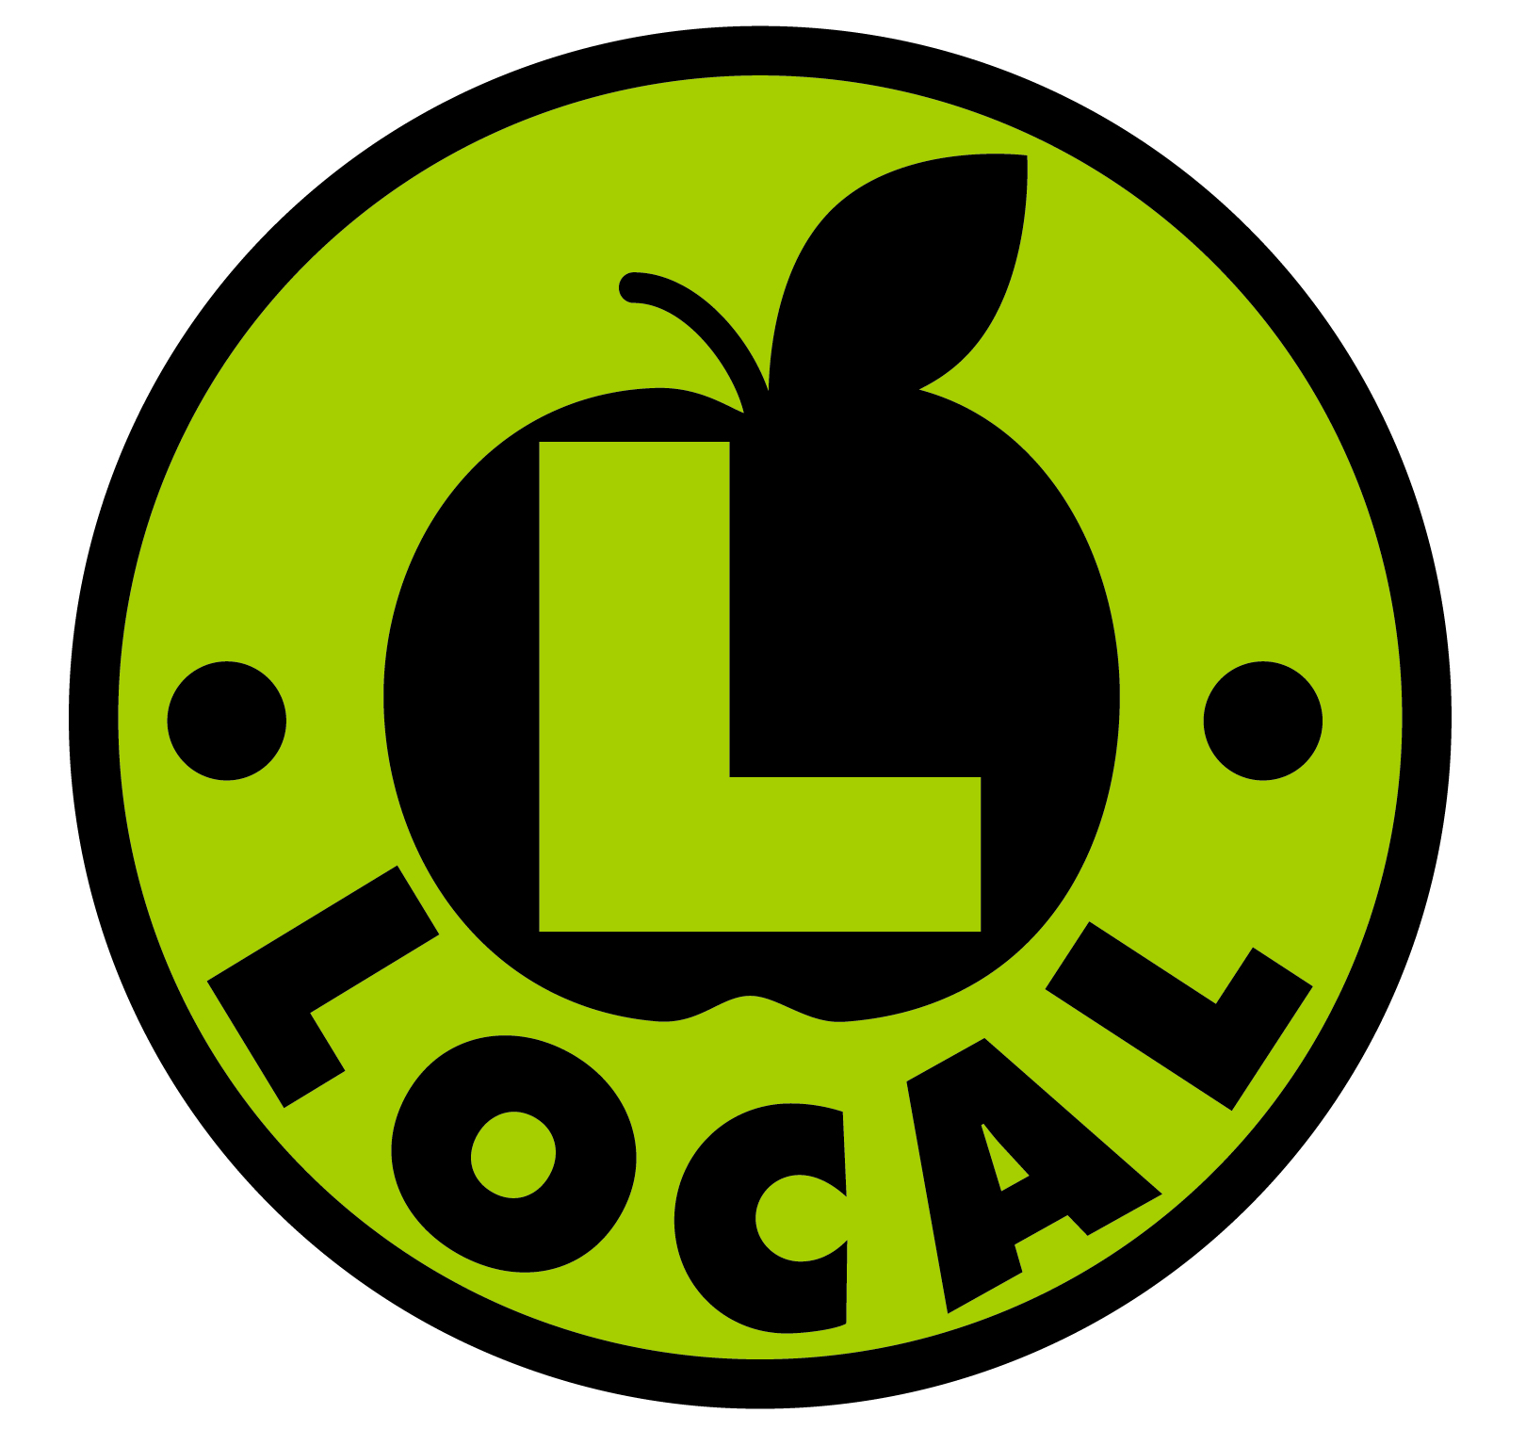 Wheatgrass Shot (1 oz.)
$1.99

Wheatgrass Fusion (80z.)
Wheatgrass, Orange Juice, Maca, Cyclone Cider $4.99

Elderberry Shot (1 oz.)
$1.50

Raw Hot Chocolate (8 0z.)
Cacao, Date, and Hempseed
$3.99

Why Organic?

Organic, in relation to produce, is grown naturally, without pesticides, synthetic fertilizers, sewage sludge, GMOs, or ionizing radiation. It is clean food for your body and you can feel good about what you’re eating because you know how it was produced and you know exactly what you’re putting in to your body.

How To Cleanse

Are you ready to detoxify your body? If so, look no further than our Fresh, Organic Juice! We offer our specialty juices or you may create your own unique juice for your cleanse. We have 64 oz. and 128 oz. containers available to purchase for your cleansing delight in the store, or you may bring in your own container(s) for your cleanse. While we recommend doing a full, 3 Day Cleanse, we do offer 1 Day and 2 Day sizes as well. For any other questions in regards to doing a cleanse, feel free to speak with any of our knowledgeable juicers!

1 Day (64 oz.): $34.00*
2 Day (128 oz.): $67.00*
3 Day (192 oz.): $99.00*
*These prices include a tip

Follow Us Online!

Our Website, where you can find information on upcoming events and sales in the store is below, as well as a couple of our social media sites with quick access QR Codes, too!

www.harmony-farms.net

Get updates on Facebook
/HarmonyFarmsNC

Follow us on Twitter @HarmonyFarmsNC

We’d also like to thank our partners from Hilltop Farms (the only Certified Organic Farm in Wake County), Eastern Carolina Organics (distributors of NC Organic Produce), and Albert’s Organics (distributor of local, regional, and international Organic Produce) for providing us with as much local, organic produce possible. Thank you!

Organic Juice
and
Smoothie Bar

Store Hours

Monday-Saturday
9am-8pm

Sunday
11am-6pm

Juice Bar Hours

Monday-Saturday
9am-6pm

Sunday
11am-6pm

5653 Creedmoor Road
Raleigh, NC 27612

919-782-0064

